Miles Porter – Tu/Th

CS 2050 Technical Documentation – Module 03
Interfaces
Abstract Classes vs Interfaces
Array Lists
Input Validation
Input from File
Stacks
Queues
Generics
Singly Linked Lists
Doubly Linked Lists

Interfaces
- An interface defines a contract that tells implementing classes which methods they must provide.
- Interfaces are useful when different classes need to share the same behavior without sharing the same parent class.
- An interface focuses on what a class must do, not how it does it.
- Interfaces improve flexibility because multiple classes can implement the same contract in different ways.
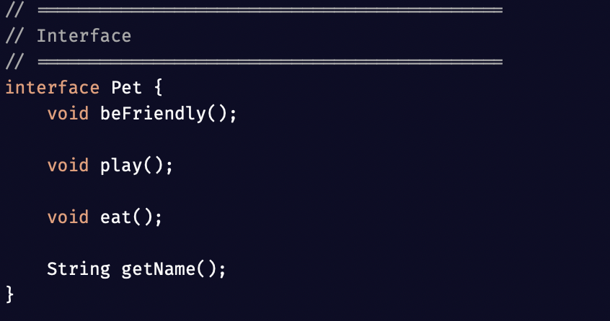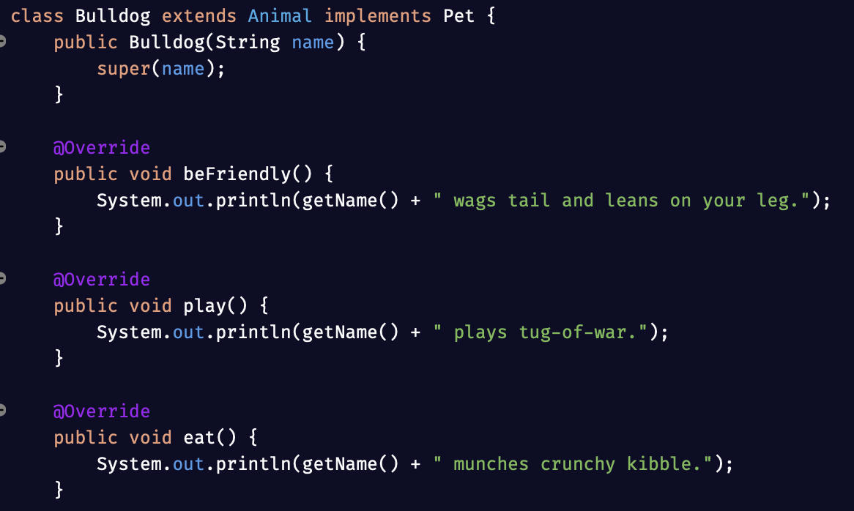

Abstract Classes vs Interfaces
- An abstract class is used when related classes should share common fields or methods.
- An interface is used when classes only need to share required behavior.
- Abstract classes can contain both abstract methods and fully implemented methods.
- Interfaces are better for defining capabilities that many unrelated classes can share.
- A class can only extend one abstract class, but it can implement multiple interfaces.
- I would use an abstract class for a strong parent-child relationship and an interface for shared abilities.
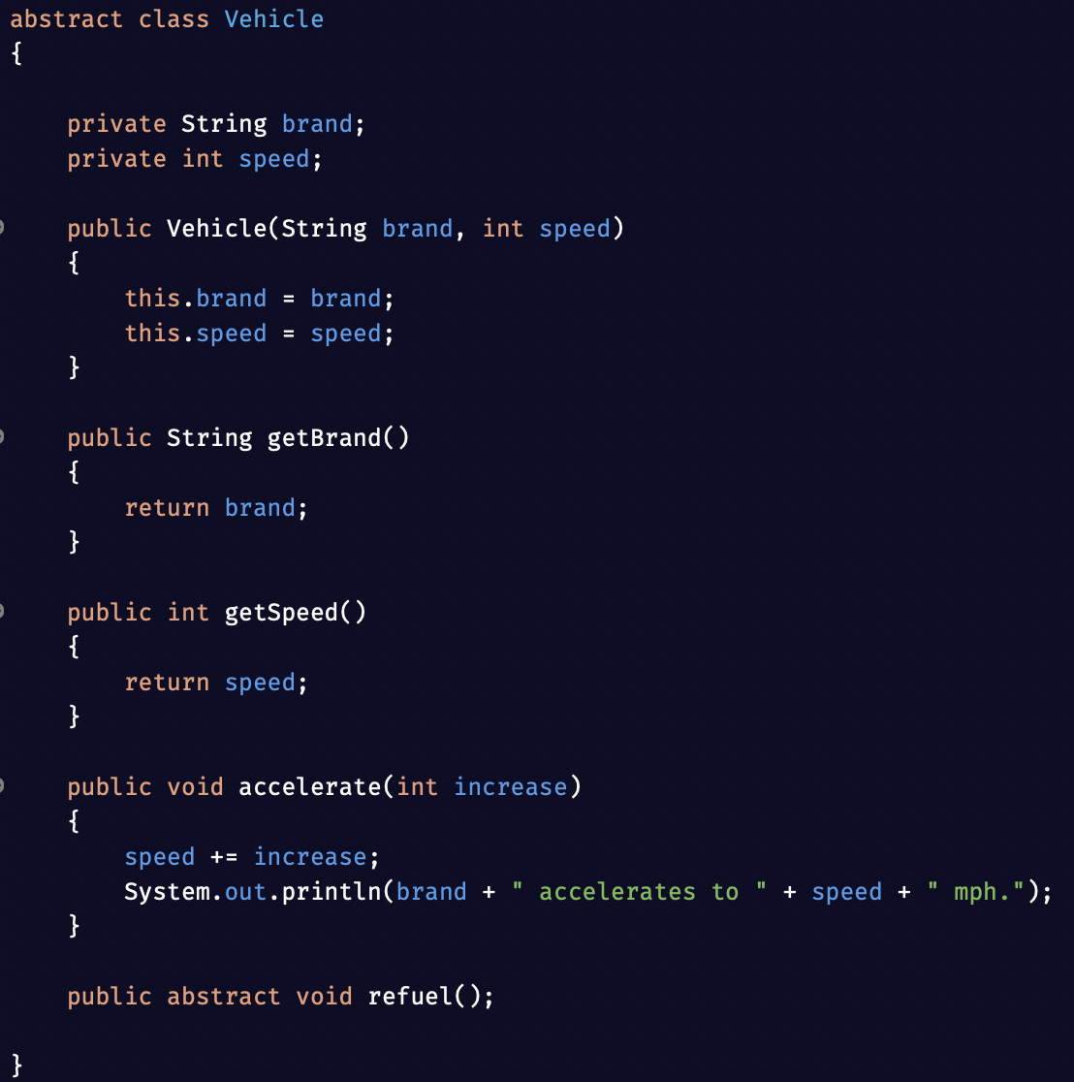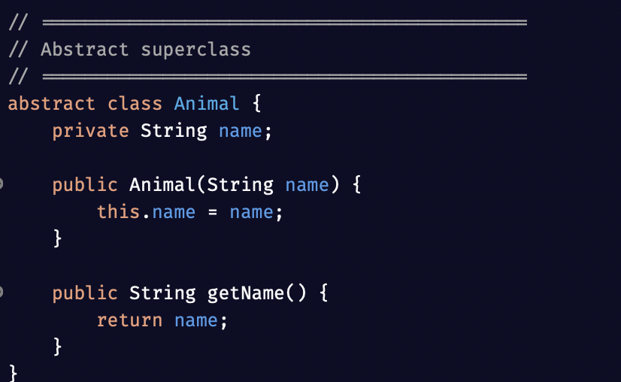

Array Lists
- An ArrayList is a resizable collection that can grow or shrink as needed.
- ArrayList is useful when the number of items is not known ahead of time.
- Elements can be added, removed, searched, and accessed by index.
- ArrayList is easier to manage than a normal array when the collection size changes often.
- add() inserts a new element into the list.
- get() accesses an element by index.
- contains() checks whether a value exists in the list.
- remove() deletes an element from the list.
- size() returns the current number of items in the list.
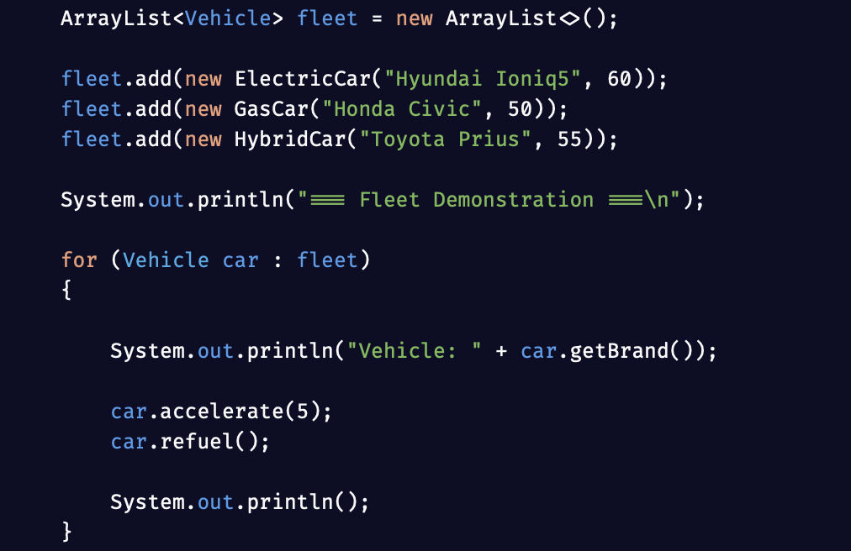

Input Validation
- Input validation prevents bad data from crashing the program.
- Validation checks whether the user entered the right type of value before processing it.
- Validation is important because users may enter letters when numbers are expected.
- Re-prompting the user makes the program more reliable and user-friendly.
- hasNextInt() checks whether the next input is actually an integer.
- kb.next() clears the invalid token so the loop can continue.
- This prevents the program from failing on incorrect input.
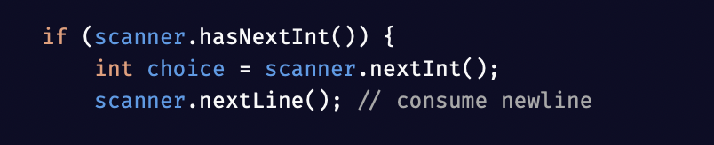
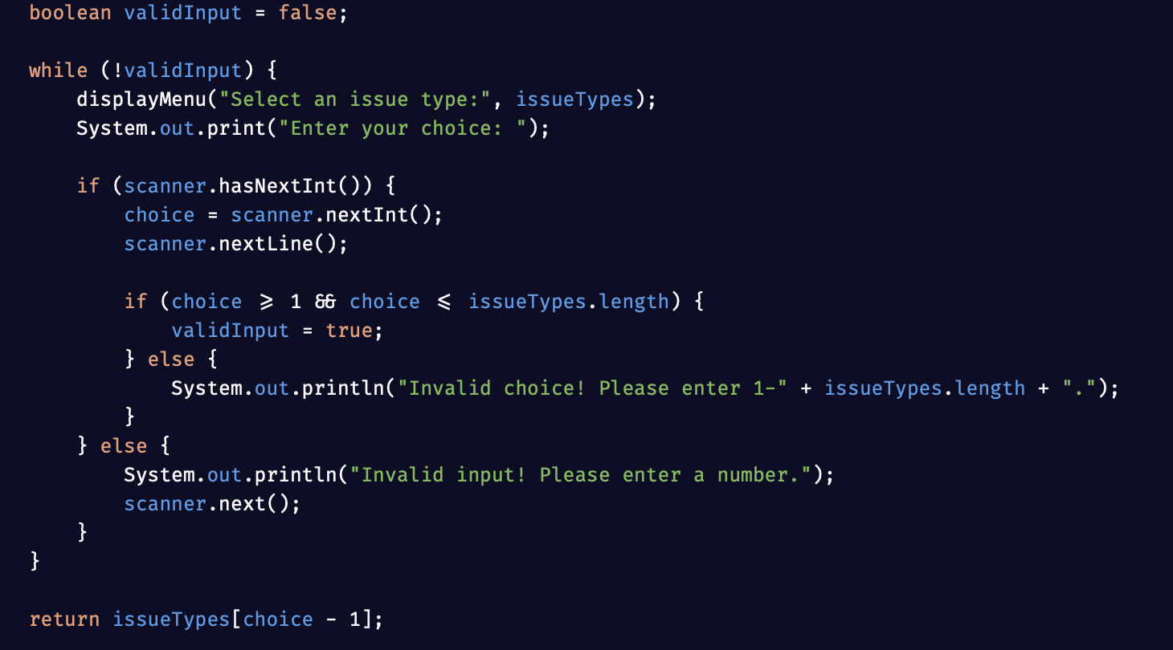

Input from File
- File reading allows a program to load saved data instead of requiring manual input every time.
- The File class is used to locate the file on the system.
- The Scanner class can read the file line by line.
- Structured file data can be split into parts and used to build objects.
- hasNextLine() checks whether there is more data to read.
- nextLine() reads one full line from the file.
- split(",") separates structured text into usable pieces.
- This approach is useful when loading objects from CSV-style files.
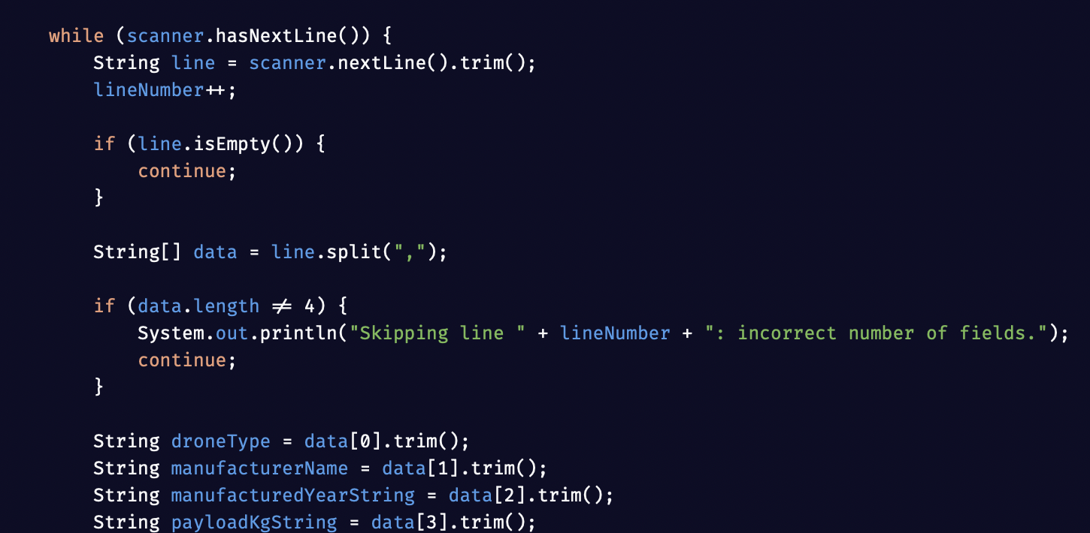

Stacks
- A stack is a linear data structure that follows LIFO, which means last in, first out.
- The most recently added item is the first one removed.
- Stacks are useful for undo features, browser history, and expression processing.
- Stack operations are usually simple and fast because all work happens at the top.
- push() adds an item to the top of the stack.
- pop() removes and returns the top item.
- peek() returns the top item without removing it.
- In this example, "Page 3" is removed first because it was added last.
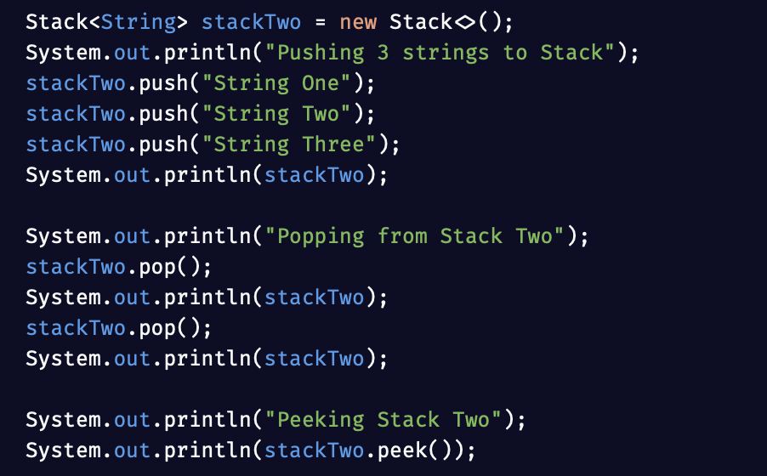
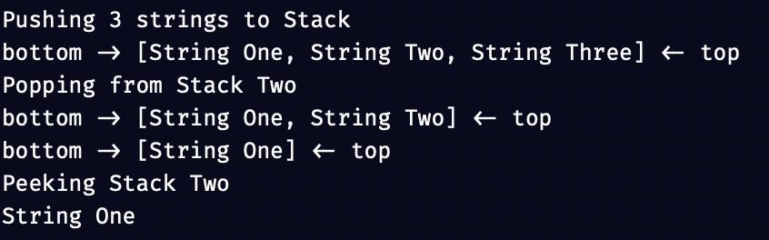

Queues
- A queue is a linear data structure that follows FIFO, which means first in, first out.
- The earliest added item is the first one removed.
- Queues are useful for task scheduling, waiting lines, and print jobs.
- A queue processes items in the same order they arrived.
- peek() returns the front item without removing it.
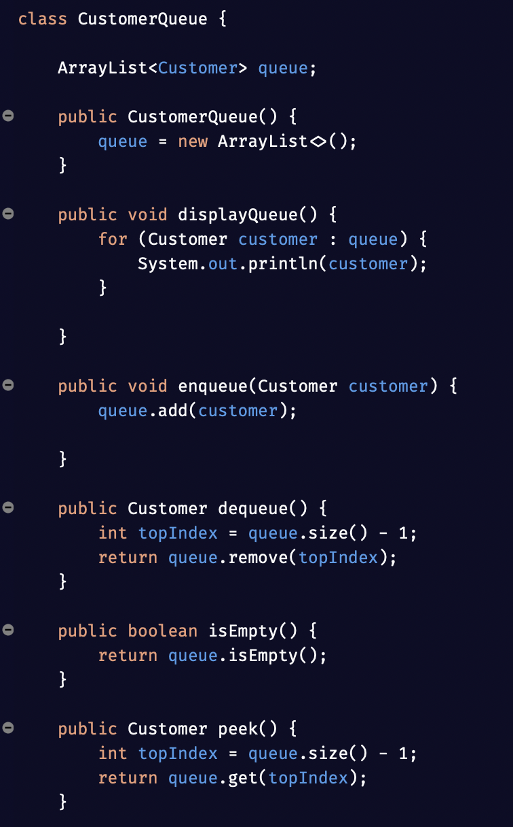

Generics
- Generics allow classes and methods to work with different data types safely.
- Generics improve reusability because the same code can work with many object types.
- Generics improve type safety because the compiler checks data types at compile time.
- Generics reduce the need for casting.

Singly Linked Lists
- A singly linked list stores data in nodes connected by references.
- Each node stores a value and a reference to the next node.
- Singly linked lists are good for insert and delete operations when shifting elements would be inefficient.
- Traversal moves through the list one node at a time from front to back.
- head stores the starting point of the list.
- Each node points only to the next node in the chain.
- traverse() visits each node until reaching null.
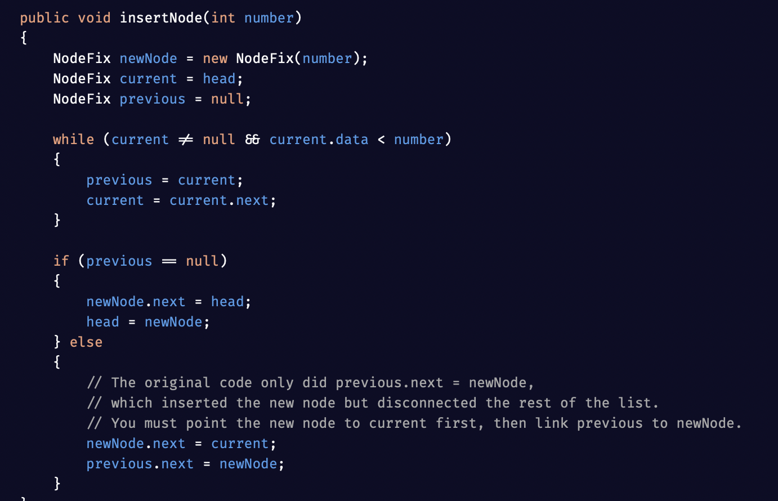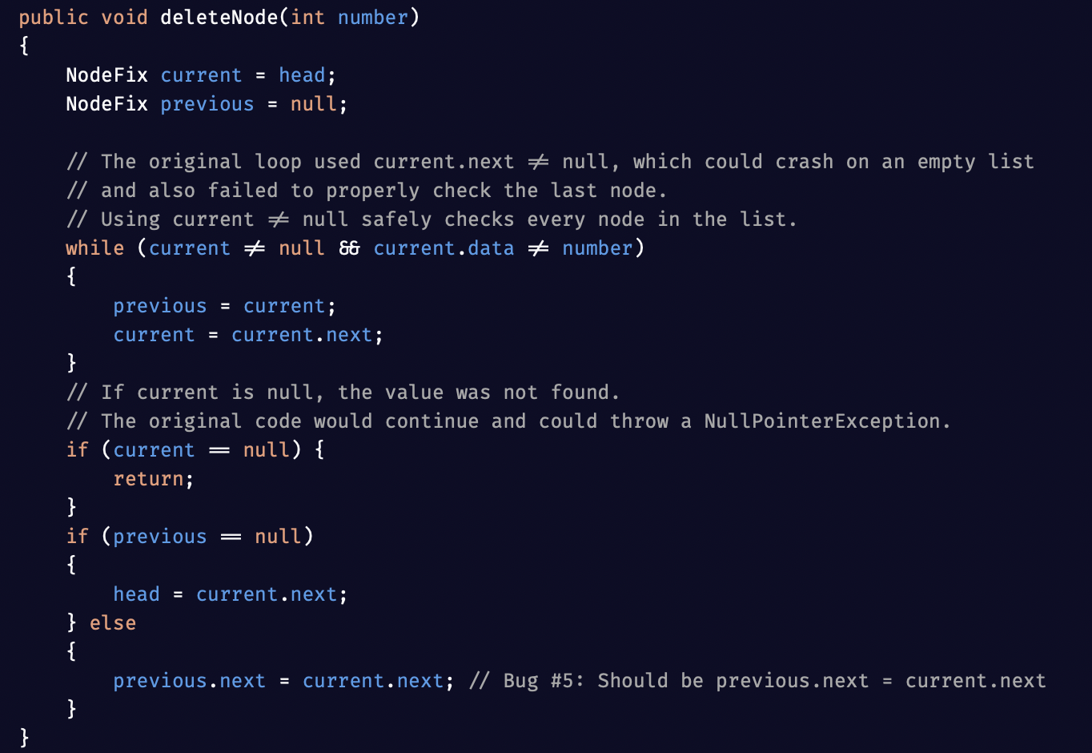
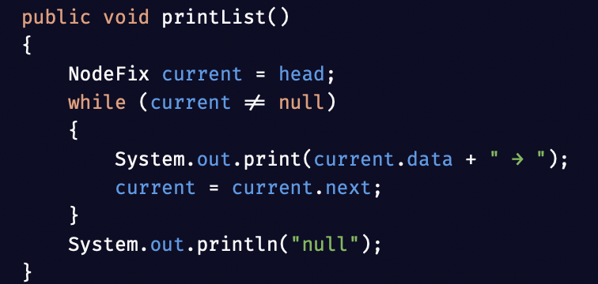

Doubly Linked Lists

- A doubly linked list gives each node both a next reference and a prev reference.
- Doubly linked lists allow movement in both forward and backward directions.
- Deletion is more flexible because each node can access its neighboring nodes directly.
- Doubly linked lists use more memory because every node stores two references.
- next points to the next node in the list.
- prev points to the previous node in the list.
- This structure improves navigation but costs more memory than a singly linked list.

